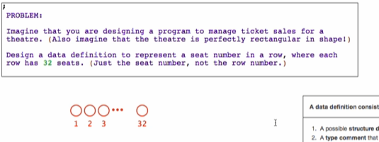

Go to Design Recipe: <https://courses.edx.org/courses/course-v1:UBCx+HtC1x+2T2017/77860a93562d40bda45e452ea064998b/#Atomic>

* 
* 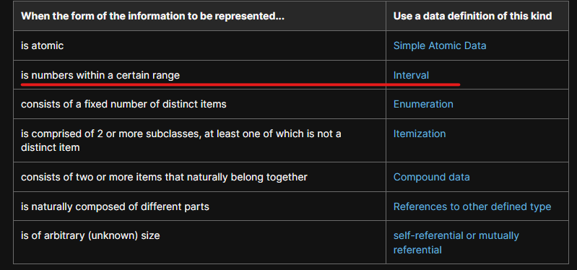
* Intervals:
* 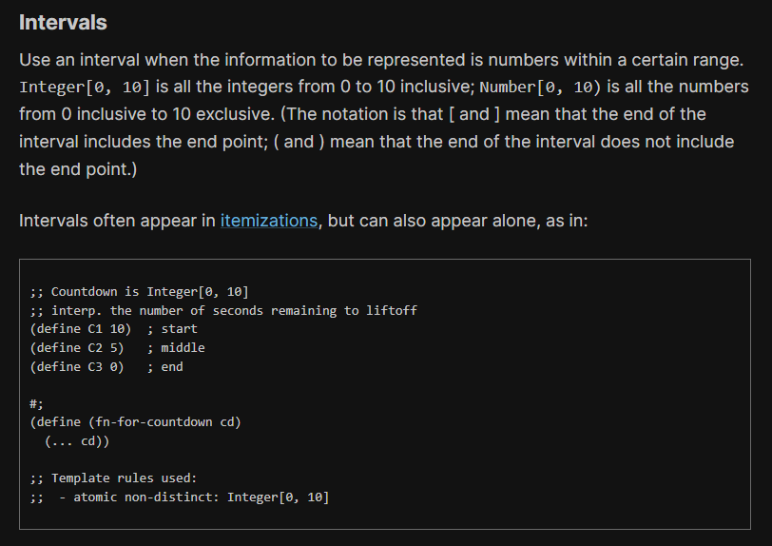

**Type Comment**



[] – inclusive

* Start and end is included in the range

() – exclusive

* Start and end not included

(], [) – mixed,’(‘ for not included, ‘]’ for included

* Eg: 

**Interpretation**



**Examples**



**Template**

Structure the template first with the comment of Template rules used:

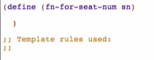

Go back to Intervals at Design Recipe

Under Forming the Template, click the Data Driven Templates recipe

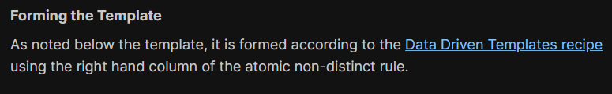

Find interval

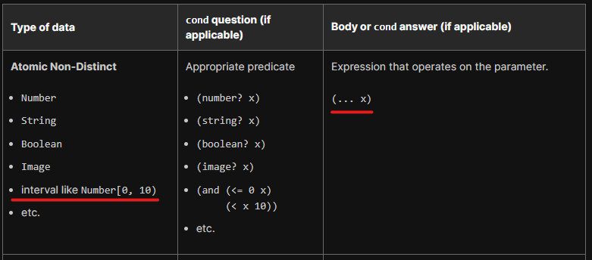

Apply in template and record the template rule used

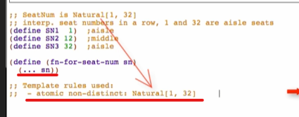

Run and check if everything is well formed!